Disadva->

1.Enumeration is only valid for legacy element.

2.

Iterator->

1.universal use.for all collection.

2.we can perform read and remove.//not in enume..

Public Iterator Iterator()

Iterator itr=c.iterato();

//c is any collection object.

Methods->

1.public boolean hasnext()

2.public Object next()

\*3.public void remove()

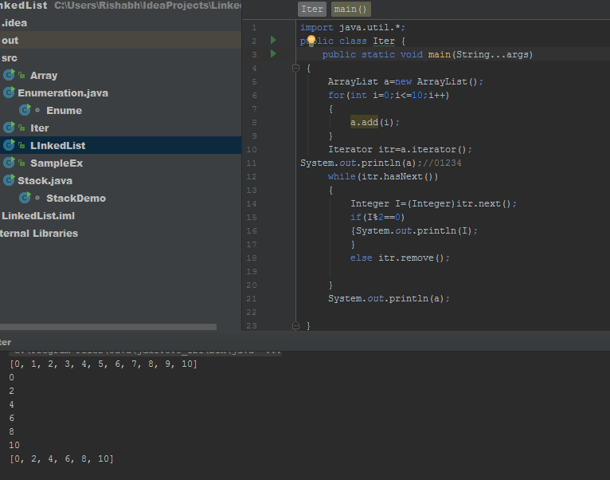

Limitations of iterator->

1.enumeration and iterator are single direction directions..its cant go back and read the object.

2.replace ,addition of object is not there.

Note ->to overcome above limits we prefer to listiterator.